£40.00 Per Person – Non Refundable Deposit Required On Booking

Monday 20th May – Friday 24th May 2024

WARNER’S HOLME LACY HOUSE
ADULTS ONLY HOTEL
HEREFORDSHIRE – 5days/4nights

This Grade I listed mansion was completed in 1674 and was reportedly visited by Charles II, and William Pitt, 1st Earl of Chatham, who held cabinet meetings in the gardens. Set in 20 acres of gardens in the Wye Valley, Holme Lacy is one of Herefordshire’s treasures.

Warner Breaks are a complete adult's only holiday package, including dinner, bed and breakfast, live entertainment and leisure activities. By day you can just relax, enjoy one of our excursions or take part in the many activities including dancing, games and quizzes. Warner Breaks offer a range of activities such as archery, tennis and croquet. Have a swim in the heated swimming pool, relax in the spa pool, steam room and sauna or enjoy a beauty treatment.

This week entertain includes Cirque - The Greatest Show: Warner present this spectacular theatre production,
plus Sabatino & Sutcliffe 'Sing The Songs Of Ball & Boe'

With excursions Including Hereford, Ross on Wye & River Wye Boat Cruise.
Price - £456.00 per person – Standard Room
Price - £486.00 per person – Signature Room

Register Of Interest for Single Rooms

4 Nights’ accommodation in a either a Standard or Ambassador Room
Meals on a half board basis (Breakfast & Dinner), Nightly Entertainment and Daily Activity Programme
Coach travel and services of Magic Moments Tour
Manager throughout
And 2 mid-week excursions / 1 day off at leisure

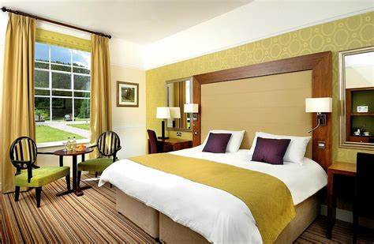

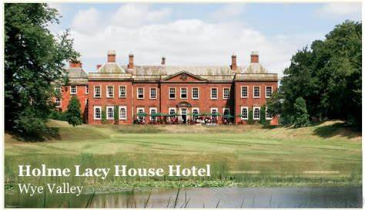

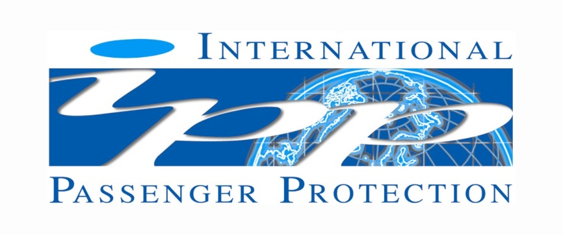

MAGIC MOMENTS FINANCIAL FAILURE HOLIDAY INSURANCE

In accordance with the UK Package Travel & Linked Travel Regulations 2018 all passengers booking with Andrew Holden t/a Magic Moments are fully protected for the initial deposit and subsequently the balance of all monies received by us, including repatriation costs and arrangements, arising from cancellation or curtailment of your travel arrangements due to the insolvency of Andrew Holden t/a Magic Moments

There is no requirement for Financial Protection of day trips or single elements, and none is provided.

Andrew Holden t/a Magic Moments has taken out an insurance provided by International Passenger Protection Ltd (IPP) with Liberty Mutual Insurance Europe SE (LMIE) trading as Liberty Specialty Markets, a member of the Liberty Mutual Insurance Group. LMIE's registered office: 5-7 rue Leon Laval, L-3372, Leudelange, Grand Duchy of Luxembourg, Registered Number B232280 (Registre de Commerce et des Sociétés). LMIE is a European public limited liability company and is supervised by the Commissariat aux Assurances and licensed by the Luxembourg Minister of Finance as an insurance and reinsurance company. This insurance is only valid for passengers who book and pay directly with/to Andrew Holden t/a Magic Moments

In the event of our insolvency please make contact as soon as practically possible giving full details of what has happened quoting the name of your Travel Operator:

IPP Claims at Sedgwick
Telephone: +44 (0)345 266 1872
Email: Insolvency-claims@ipplondon.co.uk
or online at http://www.ipplondon.co.uk/claims.asp

